**Bike Route Optimization. Joe Hardy is a W. P. Carey student and lives at 12Fifty5 on East University Drive. He rides his bike to school every day. Once, network flow models were taught to him, he was curious to minimize the time taken by him to reach McCord Hall from 12Fifty5. The average speed at which he rides is 5 ft/sec. Stop boards add 3 sec. and Signals add 45 sec. to the travel time. Stop boards are placed on network arcs meaning only if you travel through that arc it will affect you but, traffic lights are placed on nodes meaning whichever route you take, If you are planning to reach a node with a light, it will affect you. Traffic lights will affect you only when you are going into a node and not when you are going out of one.**

***12Fifty5 to McCord Hall Google Map***

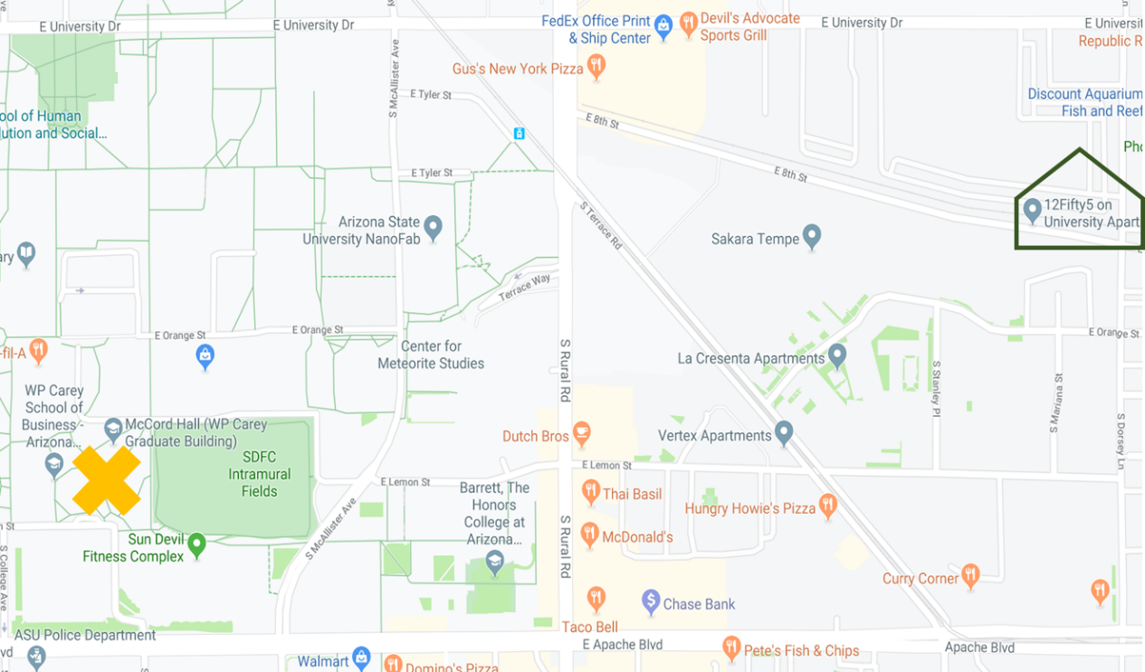

***Simplified Rendering of the above map***

